PCA with varimax rotation-to see what it does
A factor analysis was run on a sample size of 500 participants from the National Education Longitudinal Study of 1988. The dimensionality of the three selected groups of items form variables (mathematics belief, mathematics classroom attitude and emphasis on mathematics) was analyzed using the principle components factor analysis. These criteria were used to determine the number of factors to rotate: the prior hypothesis that the measure was unidimensional, the scree test and the extraction method.
The scree plot indicated that the original hypothesis was incorrect. Based on the plot (Figure 1), four factors were rotated using the varimax procedure. The rotated solution (Table 1) yielded four interpretable factors. The extraction method used was Principal Component Analysis. There are 47 (34.0%) nonredundant residuals with absolute values greater than 0.05, which is acceptable.
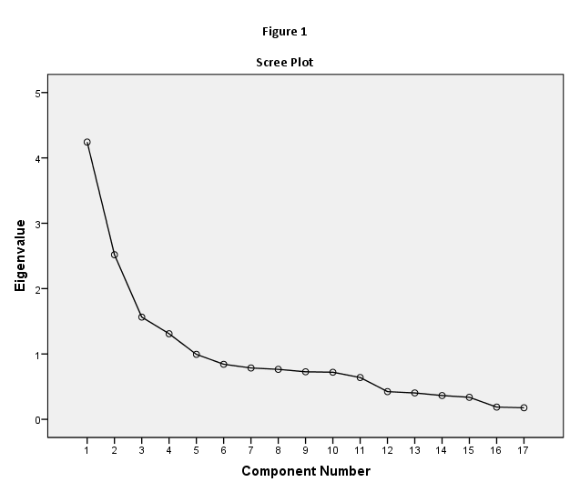

Table 1
Rotated Component Matrixª
 | Component
 | 1 | 2 | 3 | 4
f2s20c | .785
f2s20d | .756
f2s20e | .754
f2s20a | .750
f2s20b | .616
f2s19bf
f1s63d |  | .912
f1s63q |  | .911
f1s63j |  | .894
f1s63s |  | -.556
f2s19bb |  |  | .862
f2s19bc |  |  | .761
f2s19ba |  |  | .573
f2s19bd |  |  |  | .735
f2s19bg |  |  |  | .644
f2s19be |  |  |  | .602
f2s19bi |  |  |  | .558
Extraction Method: Principal Component Analysis.
Rotation Method: Varimax with Kaiser Normalization.
a. Rotation converged in 5 iterations.

FA with Principal Axis Factoring with oblique rotation, here you will try and determine the best model
A factor analysis was run on a sample size of 500 participants from the National Education Longitudinal Study of 1988. The dimensionality of the three selected groups of items form variables (mathematics belief, mathematics classroom attitude and emphasis on mathematics) was analyzed using the principle axis factor analysis. These criteria were used to determine the number of factors to rotate: the prior hypothesis that the measure had three groups, the scree test and the extraction method.
The scree plot indicated that the original hypothesis was incorrect. Based on the plot (Figure 2), four factors were rotated using the Direct Oblimin procedure. The rotated solution (Table 2 & 3) yielded four interpretable factors. There is very little overlap within the groups. The extraction method used was Principal Axis Factoring . There are 8 (5.0%) nonredundant residuals with absolute values greater than 0.05.here are 47 (34.0%) nonredundant residuals with absolute values greater than 0.05, which is a good sign.

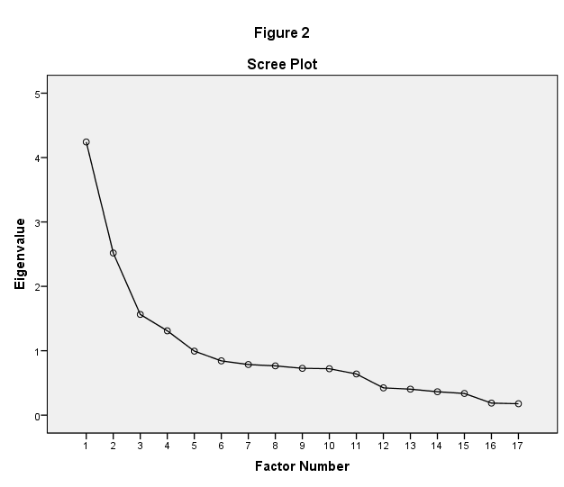

Table 2
Pattern Matrixª
 | Factor
 | 1 | 2 | 3 | 4
f2s20c | .789
f2s20d | .715
f2s20e | .694
f2s20a | .683
f2s20b | .513
f2s19bf
f1s63q |  | -.908
f1s63d |  | -.904
f1s63j |  | -.878
f1s63s |  | .412
f2s19bb |  |  | -.973
f2s19bc |  |  | -.588
f2s19ba
f2s19bd |  |  |  | .626
f2s19be |  |  |  | .474
f2s19bg |  |  |  | .439
f2s19bi
Extraction Method: Principal Axis Factoring.
Rotation Method: Oblimin with Kaiser Normalization.
a. Rotation converged in 6 iterations.

Table 3
Structure Matrix
 | Factor
 | 1 | 2 | 3 | 4
f2s20c | .788
f2s20d | .770 |  | -.433
f2s20e | .696
f2s20a | .695
f2s20b | .510
f2s19bf
f1s63d |  | -.905
f1s63q |  | -.901
f1s63j |  | -.884
f1s63s |  | .407
f2s19bb |  |  | -.912
f2s19bc |  |  | -.644
f2s19ba |  |  | -.427
f2s19bd |  |  |  | .603
f2s19be |  |  |  | .523
f2s19bi |  |  |  | .445
f2s19bg |  |  |  | .424
Extraction Method: Principal Axis Factoring.
Rotation Method: Oblimin with Kaiser Normalization.

FA with maximum likelihood and oblique rotation, here you will try and determine the best model
A factor analysis was run on a sample size of 500 participants from the National Education Longitudinal Study of 1988. The dimensionality of the three selected groups of items form variables (mathematics belief, mathematics classroom attitude and emphasis on mathematics) was analyzed using the maximum likelihood factor analysis. These criteria were used to determine the number of factors to rotate: the prior hypothesis that the measure had three groups, the scree test and the extraction method.
The scree plot indicated that the original hypothesis was incorrect. Based on the plot (Figure 3), four factors were rotated using the Direct Oblimin procedure. The rotated solution (Table 4 & 5) yielded four interpretable factors. There is a slight overlap in two of the factors. The extraction method used was Maximum Likelihood. There are 11 (8.0%) nonredundant residuals with absolute values greater than 0.05, which is also good.

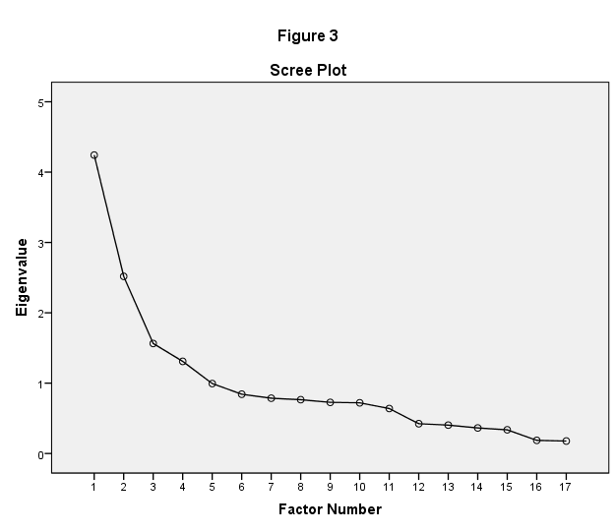

Table 5
Pattern Matrixª
 | Factor
 | 1 | 2 | 3 | 4
f1s63q | .905
f1s63d | .898
f1s63j | .892
f1s63s | -.411
f2s19bb |  | .988
f2s19bc |  | .593
f2s19ba
f2s20c |  |  | .785
f2s20d |  |  | .713
f2s20a |  |  | .671
f2s20e |  |  | .666
f2s20b |  |  | .535
f2s19bf
f2s19bd |  |  |  | .640
f2s19be |  |  |  | .464
f2s19bg |  |  |  | .421
f2s19bi
Extraction Method: Maximum Likelihood.
Rotation Method: Oblimin with Kaiser Normalization.
a. Rotation converged in 6 iterations.

Table 6
Structure Matrix
 | Factor
 | 1 | 2 | 3 | 4
f1s63d | .897
f1s63q | .897
f1s63j | .896
f1s63s | -.406
f2s19bb |  | .923
f2s19bc |  | .650
f2s19ba |  | .427
f2s20c |  |  | .786
f2s20d |  | .424 | .769
f2s20a |  |  | .694
f2s20e |  |  | .690 | .415
f2s20b |  |  | .521
f2s19bf
f2s19bd |  |  |  | .614
f2s19be |  |  |  | .512
f2s19bi |  |  |  | .434
f2s19bg |  |  |  | .407
Extraction Method: Maximum Likelihood.
Rotation Method: Oblimin with Kaiser Normalization.

Just from looking at the three examples, the best method seems to be FA with Principal Axis Factoring with oblique rotation.
For the IPOP data there are 38 items, 203 people, and one ID variable. The scale used for this Likert-type survey is “not me at all,” “a little me,” “me,” and “very much me.” For the analysis of IPOP you can choose the method and rotation etc. You are to come up with the best model and try to name the factors.
I am torn between the two following methods: The first has more factors identified, but there is some overlap that makes the identification of factor names hard. The second method yielded only six factors, but a lot of the questions were left out of the factors because I left out coefficients under .4. When I changed it to .3, I got overlap again in a lot of the factors.
----
A factor analysis was run on a sample size of 203 participants. The dimensionality was analyzed using the principle axis factor analysis. These criteria were used to determine the number of factors to rotate: the prior hypothesis that the measure had three groups, the scree test and the extraction method.
The scree plot indicated that the original hypothesis was incorrect. Based on the plot (Figure 4), six factors were rotated using the Direct Oblimin procedure. The rotated solution (Table 6) yielded six interpretable factors:
- Insightfulness, Intellectual, Introvert
- Social, Understanding, Extrovert
- Physical, Kinesis, Nature
- Creative, Critical Thinking
- Technology, Information, Shopping
- Abstract, Artistic
There is slight overlap in a few of the factors. The extraction method used was Principal Axis Factoring. b. Residuals are computed between observed and reproduced correlations. There are 71 (10.0%) nonredundant residuals with absolute values greater than 0.05.

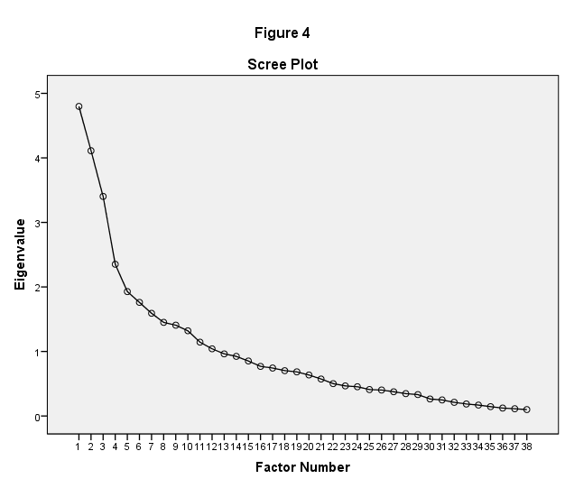

Factor Matrixª
 | Factor
 | 1 | 2 | 3 | 4 | 5 | 6 | 7 | 8 | 9 | 10 | 11 | 12
ThinkAboutMyLife | .721
InsightsIntoSelf | .709
LearnPhilosophy | .677
UnderstandPersonalityTypes | .613
WriteInJournal | .551 |  |  | -.439 | .512
AnalyzeSituations | .533
KeepJournal | .507 |  |  | -.442
SitAlone | .439
MoviesMakeMeThinkAboutMyLife | .425
KnowReasons | .415
HelpOthers
TalkAboutFamilies |  | .679
LeisureWithOthers |  | .654
IdentifyPatterns | .414 | -.614
EmotionallyConnectWithOthers | .424 | .591
DivideIntoCategories |  | -.501
BringPeopleTogether |  | .480
HowThingsAreMade |  | -.467 | .434 | .442
HowThingsWork |  | -.438
Dance
BuyThings
Skateboard |  |  | .620
TeachKidsSports |  |  | .597
PlaySports |  |  | .566 | -.435
ConstructThings |  |  | .546
Camp |  |  | .471
Ski
Run
YardSales |  |  |  |  | .472
ShopEbay |  |  |  |  | .453
ReadBios
PlayMusic
CollectSeashells
InspiredByNature |  |  |  |  |  |  | -.490
MakeConceptMaps
Touchthings
LivingInThePast
ConstructArgument
Extraction Method: Principal Axis Factoring.
a. 12 factors extracted. 22 iterations required.

